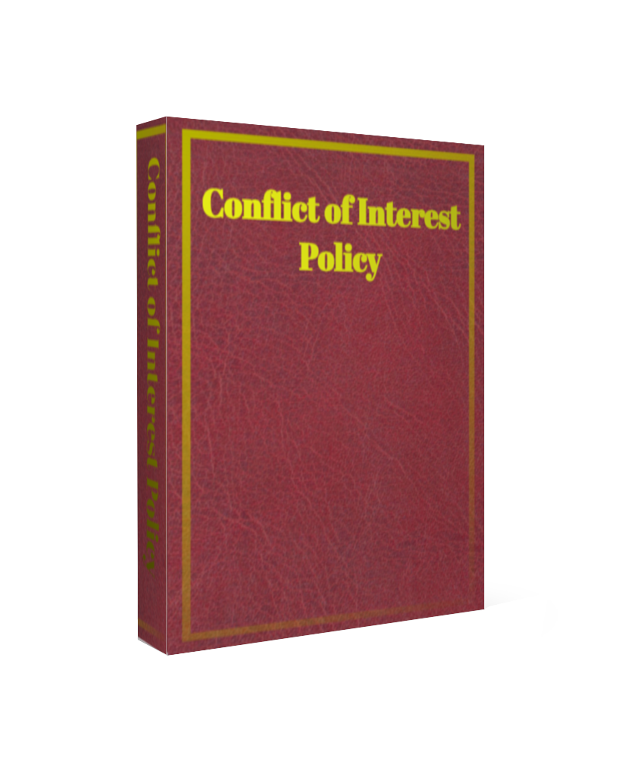

Firms Logo
Conflicts of Interest Policy
[Type the document subtitle]
[Pick the date]

Amendments to this Policy
From time to time this policy will be updated to reflect changes to {Name_of_Firm}’s regulated business or changes to the regulations to which {Name_of_Firm} is subject. The Compliance Officer will ensure that all appropriate amendments are made to this manual, and this will be overseen by the Compliance Director. The dates of the amendments are recorded below. Please ensure that you have the most up-to-date version of this manual by confirming the correct version number with Compliance.
Version | Status | Date | Amendment Comments | By Whom
0.1 | Draft | May 2016 |  | Compliance Consultant

Amend the detail on this page as required then delete this section

Variables for personalisation

{Name_of_Firm} Replace with your firm’s name

{Board/Owner/s} Replace with your firms governance requirements.
Document Governance
Policy Owner | TITLE
Approver | Board of Directors
Date approved | MONTH 20XX
Date last reviewed | MONTH 20XX
Review frequency | Annual
Next review date | MONTH 20XX
Responsible for document management | TITLE
Security classification | Restricted

Introduction

{Name_of_Firm} (the Company) have a responsibility to satisfy themselves that it, its operations and outsourced functions are properly run and have appropriate corporate governance. One of the ways in which this is achieved is to set policies for each fundamentally affected areas of business, especially those subject to regulatory scrutiny.

It is a fundamental principle of {the_Company } that it will maintain the level of integrity expected to comply with the regulatory, statutory and industry requirements applicable to its business activities. This conflicts of interest policy sets out {Name_of_Firm}’s approach to occurrence of this situation, which should ensure that {The Company} complies with all of its legal and regulatory obligations.

For many reasons, {The Company} considers it important to provide its staff with clear guidance on its archiving procedure.

Conflict of Interests

{The Company} has or may have a material interest in a transaction or a relationship that might give rise to a conflict of interest. A conflict of interest may arise between:
- {Name_of_Firm} and a customer; or
- Two different customers.

When identifying conflicts of interest, you must at least consider whether the party/parties involved:
- are likely to make a financial gain, or avoid a loss, at the expense of a customer;
- hold a differing interest in the outcome of a service or transaction provided to the customer, or of a transaction carried out on behalf of the customer, which is different to the customer’s interest;
- has a financial or other incentive to favour the interest of one customer(s) over the interests of another customer;
- carries on the same business as the customer; or
- receives or will receive from a person other than the customer an exceptional inducement in relation to the service provided.

In the event that the procedures to manage the conflict may not prevent the risk of damage, {Name_of_Firm} will be required to disclose the general nature or sources of the conflict to the customer in good time to enable the customer to make an informed decision. Do not make any disclosures to the customer without consulting your line manager and the Risk and Compliance Director first. If you have any queries on conflicts, speak to your line manager or the Risk and Compliance Director.

Inducements

{Name_of_Firm} may only pay or accept fees or commission, or provide or receive any non-monetary benefit, in relation to its regulated activities if they fall within the categories set out below:
      - The fee, commission or non-monetary benefit is paid or provided to or by a customer.
      - The fee, commission or non-monetary benefit is paid or provided to or by a third party or a person acting on behalf of a third party and:
        - The existence, nature and amount of the fee, commission or benefit, or, where the amount cannot be ascertained, the method of calculating that amount, is clearly disclosed to the customer, in a manner that is comprehensive, accurate and understandable, prior to the provision of the service; and
        - The payment of the fee or commission, or the provision of the non-monetary benefit is designed to enhance the quality of the service to the customer; and
        - The payment of the fee or commission, or the provision of the non-monetary benefit does not impair compliance with {Name_of_Firm} ’s duty to act in the best interests of the customer.
      - It is a fee which enables or is necessary for the provision of the regulated activities, such as custody costs, settlement and exchange fees, regulatory levies or legal fees, and which by their nature cannot give rise to conflicts with {Name_of_Firm} ’s duties to act honestly, fairly and professionally in accordance with the best interests of the customer.

{Name_of_Firm} will have satisfied its disclosure obligation under section 2.2 if it:
      - discloses to the customer the essential arrangements relating to the fee, commission nor non-monetary benefit in summary form; and
      - undertakes to the customer that further details will be disclosed on request; and
      - honours this undertaking.

A record of each fee, commission or non-monetary benefit it paid and/or received to another FSA authorised firm will be maintained by the Operations Department for at least 5 years from the date on which it was paid. These records will be subject to random monitoring checks by the Risk and Compliance Department.

Annual Review

This policy must be reviewed by {Name_of_Firm}’s Head of Compliance every year to ensure its alignment to appropriate legal and regulatory requirements as well as best practice compliance standards, the local whistle-blowing procedures, and its continued relevance to {Name_of_Firm}’s current and future operations. Every 12 months the {Board/Owner/s} must issue an up to date policy for {Name_of_Firm}. Any interim change to this policy must be proposed to the Board/Owners and, if agreed, requires the written approval of members of the {Board/Owner/s}.

